**CSC 249 P4 Analysis**

**Ping**

Execution Trace

Pinging www.mtholyoke.edu [23.185.0.4] 3 times using Python:

Ping 1 RTT 0.0847320556640625 sec

Ping 2 RTT 0.026190757751464844 sec

Ping 3 RTT 0.022640228271484375 sec

Avg = (85 + 26 + 23)/3 = 45 ms

Pinging www.purdue.edu [128.210.7.200] 3 times using Python:

Ping 1 RTT 0.08511090278625488 sec

Ping 2 RTT 0.2507798671722412 sec

Ping 3 RTT 0.3666701316833496 sec

Avg = (85+251+367)/3 = 234 ms

Pinging www.fsu.edu [146.201.111.62] 3 times using Python:

Ping 1 RTT 0.06243324279785156 sec

Ping 2 RTT 0.06853008270263672 sec

Ping 3 RTT 0.13190650939941406 sec

Avg = (62 + 69 + 132)/3 = 88 ms

Pinging www.ucdenver.edu [140.226.9.168] 3 times using Python:

Ping 1 RTT 0.1199958324432373 sec

Ping 2 RTT 0.21274375915527344 sec

Ping 3 RTT 0.07888007164001465 sec

Avg = (120 + 213 + 79)/3 = 137 ms

Pinging www.nmhu.edu [141.193.213.10] 3 times using Python:

Ping 1 RTT 0.0610356330871582 sec

Ping 2 RTT 0.23845624923706055 sec

Ping 3 RTT 0.11149120330810547 sec

Avg = (61 + 238 + 111)/3 = 137 ms

Pinging www.hust.edu.vn [202.191.57.199] 3 times using Python:

Ping 1 RTT 0.23692965507507324 sec

Ping 2 RTT 0.3025062084197998 sec

Ping 3 RTT 0.23732662200927734 sec

Avg = (237 + 303 + 237)/3 = 259 ms

Pinging www.louvre.fr [89.185.38.205] 3 times using Python:

Ping 1 RTT 0.15954303741455078 sec

Ping 2 RTT 0.21124053001403809 sec

Ping 3 RTT 0.20743727684020996 sec

Avg = (160 + 211 + 207)/3 = 193 ms

Pinging www.apartheidmuseum.org [116.203.242.107] 3 times using Python:

Ping 1 RTT 0.179640531539917 sec

Ping 2 RTT 0.14110183715820312 sec

Ping 3 RTT 0.1477363109588623 sec

Avg = (180 + 141 + 148)/3 = 156 ms

Pinging www.hse.ru [178.248.234.104] 3 times using Python:

Ping 1 RTT 0.08130884170532227 sec

Ping 2 RTT 0.11996603012084961 sec

Ping 3 RTT 0.1984560489654541 sec

Avg = (81 + 120 + 198)/3 = 133 ms

Pinging www.mca.com.au [13.249.190.41] 3 times using Python:

Ping 1 RTT 0.02830052375793457 sec

Ping 2 RTT 0.0196683406829834 sec

Ping 3 RTT 0.04396963119506836 sec

Avg = (28 + 20 + 44)/3 = 31 ms

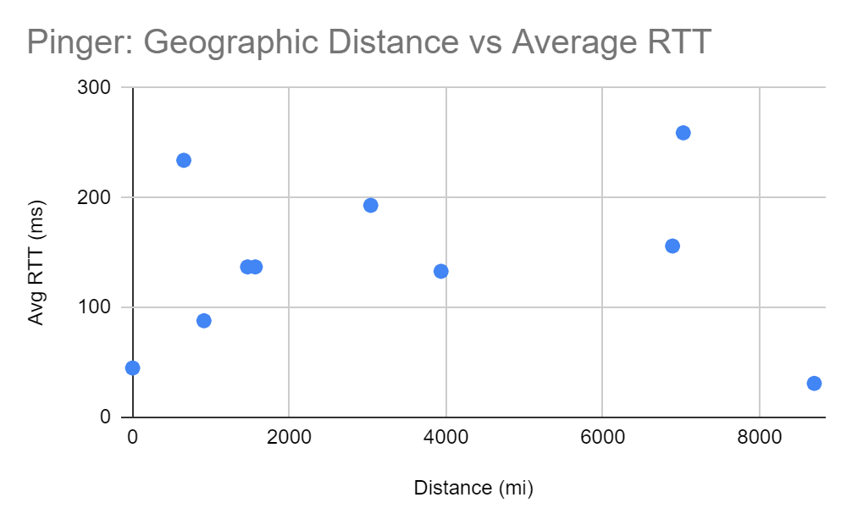

1. Are RTT and geographic distance correlated positively, negatively, or not at all? If applicable, also comment on the strength of correlation (weak vs. strong).

RTT and geographic distance seems to have a weak positive correlation, with the domain [www.mca.com.au](http://www.mca.com.au) being the most extreme outlier.

1. Why do you think you observe this trend (or lack thereof)?

I think there is a positive correlation because greater distance between the source and destination IP means that the signal sent from my device has to travel a longer length. Perhaps the correlation is weak because, depending what networks and links the signal goes through, there can be variety in the RTT for the different distances—these varieties can be influenced by the cables used and the network traffic through certain routes. Also, there might not be enough data points to show a stronger correlation.

**Traceroute**

Execution Trace

[www.mtholyoke.edu](http://www.mtholyoke.edu)

1 rtt=139 ms 138.110.152.1

2 rtt=161 ms 138.110.91.77

3 rtt=84 ms 138.110.91.74

4 rtt=108 ms 138.110.91.40

5 rtt=88 ms 134.241.249.31

6 rtt=81 ms 69.16.1.33

7 rtt=126 ms 69.16.0.9

8 rtt=82 ms 38.104.218.13

9 rtt=96 ms 154.54.41.129

10 rtt=89 ms 38.140.158.82

11 rtt=54 ms 23.185.0.4

[www.purdue.edu](http://www.purdue.edu)

1 rtt=19 ms 138.110.152.1

2 rtt=3 ms 138.110.91.77

3 rtt=31 ms 138.110.91.74

4 rtt=17 ms 138.110.91.40

5 rtt=4 ms 134.241.249.31

6 rtt=5 ms 69.16.1.33

7 rtt=3 ms 18.2.8.89

8 rtt=10 ms 192.5.89.254

9 rtt=25 ms 163.253.1.21

10 rtt=23 ms 163.253.2.17

11 rtt=21 ms 163.253.2.18

12 rtt=20 ms 149.165.254.185

13 rtt=24 ms 149.165.255.209

14 rtt=28 ms 192.5.40.85

* * * Request timed out.

* * * Request timed out.

* * * Request timed out.

* * * Request timed out.

* * * Request timed out.

* * * Request timed out.

* * * Request timed out.

* * * Request timed out.

* * * Request timed out.

* * * Request timed out.

20 rtt=33 ms 128.210.7.200

[www.fsu.edu](http://www.fsu.edu)

1 rtt=171 ms 138.110.152.1

2 rtt=45 ms 138.110.91.77

3 rtt=83 ms 138.110.91.74

4 rtt=116 ms 138.110.91.40

5 rtt=63 ms 134.241.249.31

6 rtt=3 ms 69.16.1.33

7 rtt=5 ms 18.2.8.89

8 rtt=7 ms 192.5.89.57

9 rtt=12 ms 192.5.89.222

10 rtt=39 ms 163.253.1.42

11 rtt=38 ms 163.253.1.116

12 rtt=39 ms 163.253.1.9

13 rtt=40 ms 163.253.1.135

14 rtt=48 ms 163.253.1.104

15 rtt=44 ms 163.253.2.33

16 rtt=37 ms 108.59.25.20

17 rtt=40 ms 108.59.31.158

18 rtt=41 ms 108.59.31.50

19 rtt=38 ms 108.59.25.241

20 rtt=39 ms 128.186.248.2

21 rtt=47 ms 146.201.111.62

[www.ucdenver.edu](http://www.ucdenver.edu)

1 rtt=178 ms 138.110.152.1

2 rtt=154 ms 138.110.91.77

3 rtt=192 ms 138.110.91.74

4 rtt=81 ms 138.110.91.40

5 rtt=7 ms 134.241.249.31

6 rtt=8 ms 69.16.1.33

7 rtt=4 ms 18.2.8.89

8 rtt=10 ms 192.5.89.254

9 rtt=56 ms 163.253.1.21

10 rtt=65 ms 163.253.2.17

11 rtt=73 ms 163.253.2.18

12 rtt=91 ms 163.253.1.245

13 rtt=86 ms 163.253.1.242

14 rtt=75 ms 163.253.5.43

15 rtt=69 ms 129.19.165.138

16 rtt=69 ms 140.226.3.205

* * * Request timed out.

* * * Request timed out.

* * * Request timed out.

* * * Request timed out.

* * * Request timed out.

* * * Request timed out.

* * * Request timed out.

* * * Request timed out.

* * * Request timed out.

* * * Request timed out.

* * * Request timed out.

* * * Request timed out.

23 rtt=46 ms 140.226.9.168

[www.nmhu.edu](http://www.nmhu.edu)

1 rtt=21 ms 138.110.152.1

2 rtt=6 ms 138.110.91.77

3 rtt=24 ms 138.110.91.74

4 rtt=25 ms 138.110.91.40

5 rtt=10 ms 134.241.249.31

6 rtt=17 ms 69.16.1.33

7 rtt=16 ms 18.2.136.89

8 rtt=8 ms 192.5.89.57

9 rtt=10 ms 206.53.143.9

10 rtt=9 ms 141.193.213.10

[www.hust.edu.vn](http://www.hust.edu.vn)

1 rtt=59 ms 138.110.152.1

2 rtt=44 ms 138.110.91.77

3 rtt=24 ms 138.110.91.74

4 rtt=31 ms 138.110.91.40

5 rtt=114 ms 134.241.249.31

6 rtt=69 ms 69.16.1.33

7 rtt=340 ms 65.175.24.205

8 rtt=53 ms 173.241.131.14

9 rtt=309 ms 129.250.4.102

10 rtt=208 ms 129.250.2.26

11 rtt=288 ms 129.250.3.42

* * * Request timed out.

12 rtt=212 ms 129.250.3.82

* * * Request timed out.

* * * Request timed out.

* * * Request timed out.

* * * Request timed out.

* * * Request timed out.

15 rtt=379 ms 129.250.6.121

16 rtt=560 ms 203.131.242.18

* * * Request timed out.

* * * Request timed out.

* * * Request timed out.

* * * Request timed out.

19 rtt=512 ms 118.71.255.34

20 rtt=425 ms 202.191.57.4

21 rtt=498 ms 202.191.57.199

[www.louvre.fr](http://www.louvre.fr)

1 rtt=159 ms 138.110.152.1

2 rtt=135 ms 138.110.91.77

3 rtt=157 ms 138.110.91.74

4 rtt=137 ms 138.110.91.40

5 rtt=41 ms 134.241.249.31

6 rtt=175 ms 69.16.1.33

7 rtt=116 ms 65.175.24.205

8 rtt=167 ms 89.149.130.30

9 rtt=72 ms 4.68.37.109

10 rtt=205 ms 4.69.143.178

11 rtt=311 ms 213.242.120.70

12 rtt=256 ms 212.43.193.161

13 rtt=194 ms 212.43.193.101

14 rtt=250 ms 212.43.193.149

15 rtt=423 ms 89.185.58.93

16 rtt=452 ms 89.185.38.205

[www.apartheidmuseum.org](http://www.apartheidmuseum.org)

1 rtt=28 ms 138.110.152.1

2 rtt=34 ms 138.110.91.77

3 rtt=15 ms 138.110.91.74

4 rtt=20 ms 138.110.91.40

5 rtt=4 ms 134.241.249.31

6 rtt=4 ms 69.16.1.33

7 rtt=14 ms 65.175.24.205

8 rtt=93 ms 141.136.110.41

9 rtt=110 ms 154.14.78.154

10 rtt=96 ms 213.239.245.249

* * * Request timed out.

* * * Request timed out.

12 rtt=189 ms 78.47.3.46

* * * Request timed out.

* * * Request timed out.

14 rtt=120 ms 49.12.139.25

15 rtt=665 ms 116.203.242.107

[www.hse.ru](http://www.hse.ru)

1 rtt=215 ms 138.110.152.1

2 rtt=130 ms 138.110.91.77

3 rtt=107 ms 138.110.91.74

4 rtt=82 ms 138.110.91.40

5 rtt=62 ms 134.241.249.31

6 rtt=89 ms 69.16.1.33

7 rtt=93 ms 65.175.24.205

8 rtt=153 ms 89.149.130.30

9 rtt=113 ms 4.68.37.109

* * * Request timed out.

* * * Request timed out.

11 rtt=19 ms 4.14.99.138

12 rtt=427 ms 178.248.234.104

[www.mca.com.au](http://www.mca.com.au)

1 rtt=190 ms 138.110.152.1

2 rtt=186 ms 138.110.91.77

3 rtt=137 ms 138.110.91.74

4 rtt=144 ms 138.110.91.40

5 rtt=94 ms 134.241.249.31

6 rtt=100 ms 69.16.1.33

7 rtt=75 ms 65.175.24.205

8 rtt=22 ms 89.149.130.30

* * * Request timed out.

* * * Request timed out.

10 rtt=1533 ms 52.93.76.99

11 rtt=1656 ms 52.93.76.34

12 rtt=1406 ms 150.222.71.69

* * * Request timed out.

* * * Request timed out.

* * * Request timed out.

* * * Request timed out.

* * * Request timed out.

* * * Request timed out.

* * * Request timed out.

* * * Request timed out.

* * * Request timed out.

* * * Request timed out.

18 rtt=60 ms 13.249.190.9

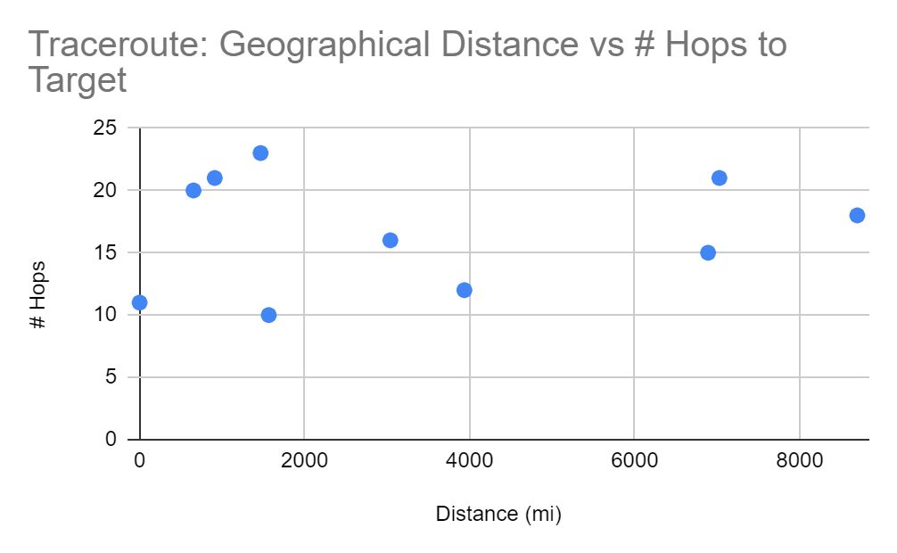

1. Are # hops and geographic distance correlated positively, negatively, or not at all? If applicable, also comment on the strength of correlation (weak vs. strong).

The # hops and geographic distance seems to have a weak positive correlation.

1. Why do you think you observe this trend (or lack thereof)?

I think there is a positive correlation because to travel through longer distances, a signal likely needs to pass through more routers to reach the final destination. The correlation seems to be weak, as some data points with a distance of less than 2000 miles have some of the highest number of hops. This could be due to greater network traffic or slower transmissions on the paths with less hops, so the signal is routed instead to a path with more hops but would perhaps take less time overall.